
London School of Science and

Technology

Pearson BTEC Level 5 Higher National Diploma in Business

Unit 6: Managing a Successful

Business Project

Assignment Title:

Module Leader:

Internal Verifier:

Issued on:

Deadline:

Submitted on:

Managing a Successful

Business Project

Ali Abbas Dar

Mohammad Haider

19th February 2018

08th June 2018

Student Name:

Student ID:

Campus: Alperton/Luton/Birmingham (delete as appropriate)

Pearson Registration Number:
MSBP

Instructions & Learner Declaration

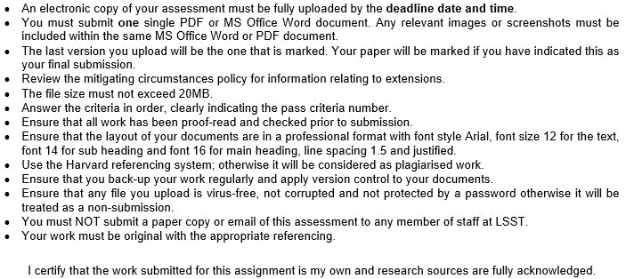

 | Signature & Date: | 1

Introduction

In this modern era of business, digital technology has greater impact on the business to run the business successfully. This research project will help the Antonelli Bros Ltd, UK to the importance and best use of the digital technology in the business. The Research project result will show the company the necessity of digital technologies for small and medium enterprise.

2

P1. Device Project aims and Objectives for Antonelli Bros Ltd

Meaning of Project and Project management

To fulfill the objectives of the company, the planned work schedule is called project (Maylor, 2010). The planning which is related with the execution of project within a proper rules and regulation is called project management. Each project and activities related with the project management is important for the organizations to carry out its each & every operations perfectly.

Project’s Title:

The following statement is considered as the project title for this assignment; it is:

“An analysis over the impact of digital technology in supporting small business growth and innovation: A case study on Antonelli Bros Ltd”

Brief Introduction of the Project

Antonelli Bros Ltd was launched in UK market in the year of 1960 to provide cones for ice cream in the UK market. The company is already established in cone & waffle business but now it wants to do business in biscuits & cookies industry of UK. The modern digital technology will help the Antonelli Bros Ltd to do this business projects perfectly just as the other competitors. Antonelli Bros Ltd can design some innovative cookies recipe and design too with the help of digital technology.

Project’s Aim

The project aim is to identify how digital technology is placing impacts over the innovation and growth of Antonelli Bros Ltd.

Project’s Objective

The objectives of the project define the main task of the projects. The following are the objectives of the current project:

- To know the practices of digital technology of Antonelli Bros Ltd in its business operations

- To identify how digital technology is effecting the growth & innovation of Antonelli Bros

Ltd

3

- To point out the relationship between digital technology and business operations

- To recommend some strategies to improve the practices of digital technology of Antonelli Bros Ltd

4

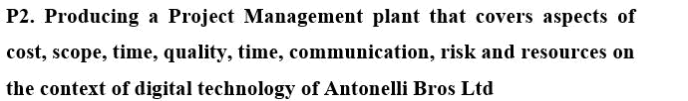

Meaning of Project Management:

Project management means the activities done by the managers to obtain a certain objective for the organization. Necessary steps and attributes are considered in a successful project management. In case of Antonelli Bros Ltd, the factors of digital technology are identified and the impact of the digital technology for the business is also identified (Eliot, 2016).

The Plan of the Project Management:

Executive Summary

Today digital technology improved the overall performance of any organization if the organization is able successful to attain digital technology. The implication of digital technology not only helps organizations to improve their overall performance but also shape up the growth of the organizations. As a result, organizations are nowadays try to get the most of the digital technology. The implication of digital technology helps organizations to set the basic platform of the operations efficiently and then affect positively on the quality of the products or services.

Strategies for the Project:

Nowadays one of the most effective way to grow the overall condition of the business is to adopt digital technology. By doing this project the manager will be able to understand the actual situation of the market as well as the customers. The manager will also be able to identify the decisions necessary to implement digital technology in the small and medium sized businesses. The project strategy will also consist of the assessment of the market situation and design strategies and tactics to improve the situation for a long-term result.

Project’s Scope:

As the growth of digital technology is an ongoing process, so the area of digital technology is vast for businesses. Organizations need to understand these areas for their own stimulate growth.

5

This project will support the business to achieve the long-term objectives and implication of the digital technology effectively. As a result the long-term planning process of Antonelli Bros Ltd will be more efficient in long-term.

Analysis of the feasibility of the Project

Project Costs

This project will be successful only when the cost of the project is lesser then the benefits of the project. To execute the project there are need of different resources where costs incurred. The estimated cost of the project would be around £ 7000. There are costs of different persons as well as some other costs. They are shown below:

Budget
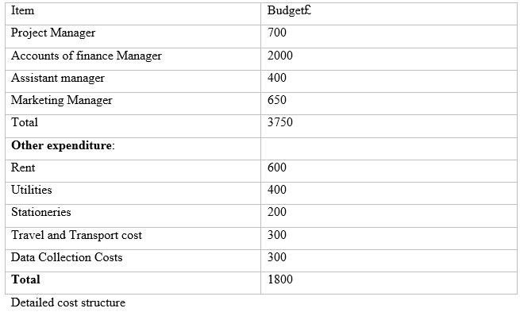

Project Time and Quality:

To make the project successful and reliable for further use the quality of the project is essential. In this case, qualitative features of the project should be considered. The project should be able to use these features to improve the decision making process of the organization (Fewings, 2013).
6

The aim of the project is to have better response for the business to keep it running for the long term. The project should increase the prosperity of the business in the most effective way. The project benefit is that it will provide an insight to itself. To complete the project the project manager has estimated 3months.

Gantt chart for the project:
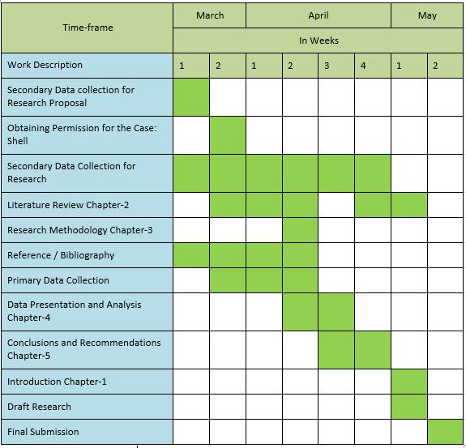

Figure: Gantt chart for the project, Source: Own

Project’s Communication Factor:

The project requires effective implementation of outputs and other implications achieved throughout the research paper. Proper communication is necessary carry out through the research in an effective manner.

Project Resource requirement:

7

Within the organisations there different types of resources that the project requires. To complete the project different attributes need different types of resources. They are given below:

The project manager followed hierarchy that is shown below:
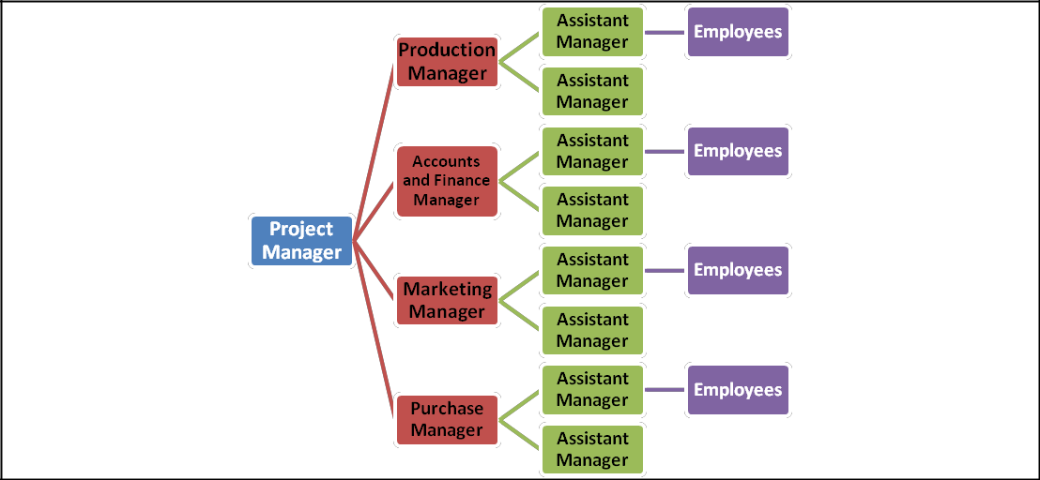

Figure: Hierarchy of the project, source: Own

As shown in the hierarchy every part of the table need to show causes to the upper body. The project manager has given a top priority to this hierarchy, as it is important to implement digital technology in the operations of the business (Scherer and Palazzo, 2008).

Material resources required for the project:

For this project in there are different types of natural resources needed such as computer, projector, and printers to complete the project in the most effective way.

Financial resources required for the project

Financial resources means the monetary help for the competition of the project. In this case, around £7,000 will be required. The project manager has included these financial supports to carry out the project successfully.

Project Risk:

The project implication in different aspects may include several types of risks and make other areas vulnerable or being influenced. Some of the risks and vulnerable points are given below:

8

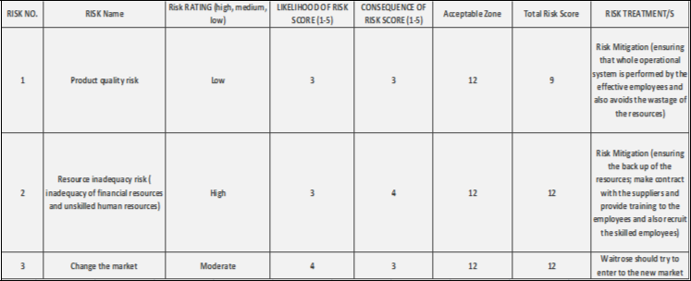

Figure: Project Risks, Source: (Unhelkar, 2011)

9

P3. Projecting a Work breakdown structure and Gantt chart to provide timeframes and stages for completion for the proposed project management plan

A work breakdown structure can be defined as the hierarchical decompositions of a several works which are to be accomplished by a project team within a particular time period. It is the way of managing different sections of project works so that these can be accomplished timely. The following Project’s work break down refers to the small activities that will be carried out by the researcher throughout the project:
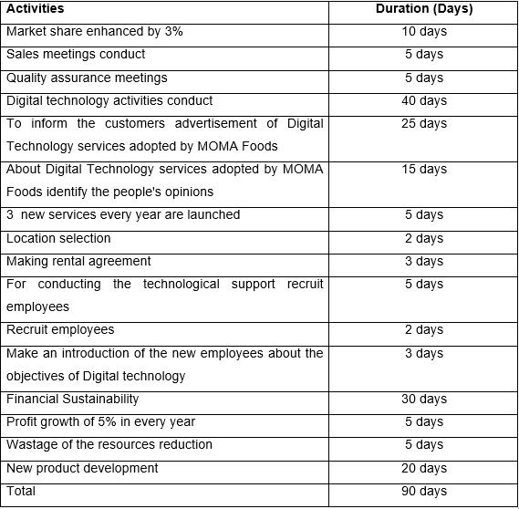

10

Project Gantt chart:

Gant chart can be defined as the graphical illustration of several work schedule of a project or research. It provides start & end time of several works which are to be accomplished within a time frame. It provides graphical representations of several project work schedule. The Following chart is representing the timetable of each action of the project related to practices of digital technology of Antonelli Bros Ltd.
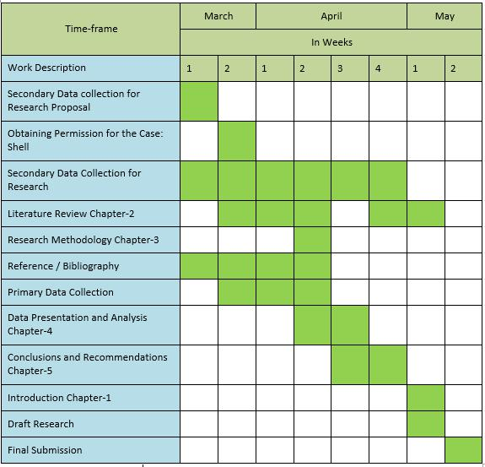

11

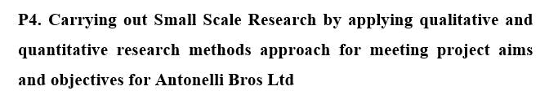

Project’s Aim

The project aim is to identify how digital technology is placing impacts over the innovation and growth of Antonelli Bros Ltd.

Project’s Objective

The objectives of the project define the main task of the projects. The following are the objectives of the current project:

- To know the practices of digital technology of Antonelli Bros Ltd in its business operations

- To identify how digital technology is effecting the growth & innovation of Antonelli Bros Ltd

- To point out the relationship between digital technology and business operations

- To recommend some strategies to improve the practices of digital technology of Antonelli Bros Ltd

12

Question of the Research

The main research question is how digital technology is placing impacts over the innovation and growth of small business companies; like Antonelli Bros Ltd?

Methods of Research project

Qualitative and Quantitative Research

Two types of research strategy are available in research method process; one is qualitative strategy and another one is quantitative strategy (Lewis, 2013). Qualitative research is the strategy which is used to get any idea or deep insight about any fact; on the other hand, quantitative research strategy provides explanation with the use of numerical data. The researcher will use the quantitative research method strategy here which will provide the researcher a good authentic perfect result containing statistical graph and chart and statistical data.

Sampling Technique & Sample size

The researcher will use the simple random sampling method in this research to choose the samples among the employees & customers of Antonelli Bros Ltd. The sample size is 100 here. 50 are the customers & 50 are the employees of Antonelli Bros Ltd.

Primary data & Secondary data

Primary data is data which is collected for the first time by the researcher to conduct the research.

Secondary data are data which is collected for the other purpose rather than the current problem.

The researcher will use the primary data in this research. Primary data will give the authentic result to the researcher. The primary data will be collected through the structured questionnaire which will be provided to the samples.

Questionnaire

13

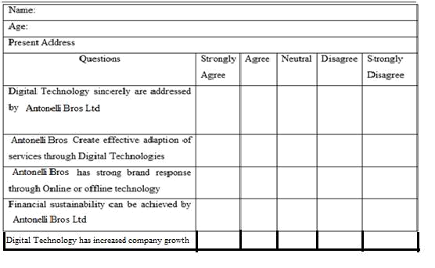

Analysis of the Collected Data:

To analyses the collected data, the researcher has used MS word & MS Excel to complete the research result which is showing in the following:

Results analysis
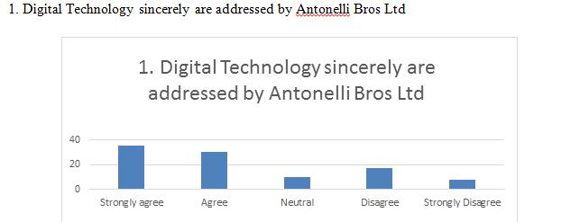

The collected data from the statement has showed that 35% of the participants of the research said strongly agree with the given statement which proved that Antonelli Bros Ltd practices and addressed the necessity of digital technology in the workplace. On the other hand, 8% of respondents has said the disagree option, that means Antonelli Bros Ltd do not addressed digital technology in the company premises.

14

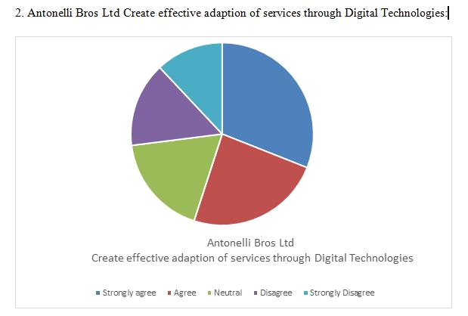

Towards the statement, 31% respondents said agree, that means Antonelli Bros Ltd provide a new

- good services to its customers to satisfy them with the help of digital technology. Again, 8% respondents think that Antonelli Bros Ltd had not adapted digital technology in their service; so they have chosen the disagree option.

15

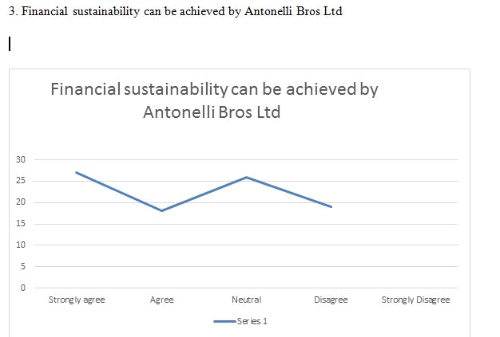

This statement is acting as a proof towards the achievement of Financial Sustainability in the company. Using digital technology in the business operation, Antonelli Bros Ltd has easily achieved financial sustainability in the workplace. Towards this statements, 27% respondents has chosen strongly agree option.

16

4. Antonelli Bros Ltd has strong brand response through online or offline technology
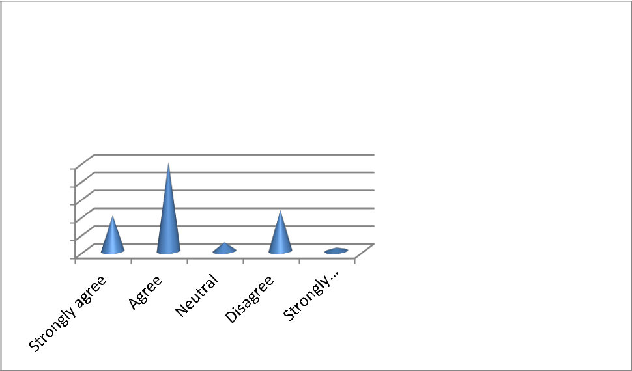

Antonelli Bros Ltd has strong brand response through online or offline technology

50
40
30
20
10
0

Antonelli Bros Ltd has strong brand response through online or offline technology

As per the research result, towards the statement Antonelli Bros Ltd has strong brand response through online or offline technology; 50 respondents has chosen the agree option. On the other hand, 23 respondents has chosen the disagree option.

5. Digital Technology has increased Antonelli Bros Ltd’s business growth
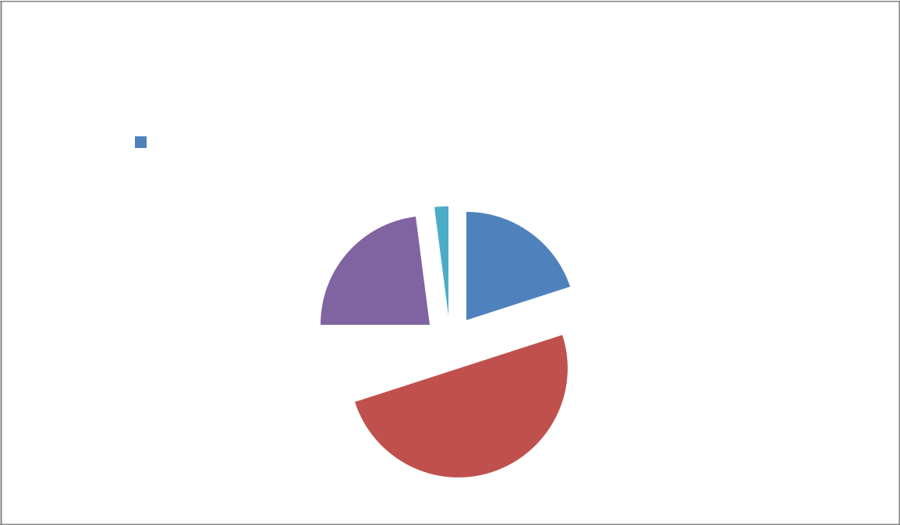

Digital Technology has increased Antonelli
Bros Ltd’s business growth

Strongly agree |  | Agree |  | Neutral |  | Disagree |  | Strongly disagree

2%

20%
23%

5% 

50%

As per the research result, towards the statement Digital Technology has increased Antonelli Bros Ltd’s business growth; 50% respondents has chosen the agree option. On the other hand, 23% respondents has chosen the disagree option.

17

Recommendation:

To maintain a growth in the operation in the business and to sustain in the market, a proper implication of digital technology is needed by the organization to enhance the company growth and company st6andards among the competitors (Holm and Jonas, 2004). Antonelli Bros Ltd should implement both different types of online & offline strategies to renovate its business operations to satisfy the customers. The company Antonelli Bros Ltd should communicate with its stakeholders through using the digital technology. It will make enable two way communication channels for Antonelli Bros Ltd.

Conclusion

At the end of this research projects, it has shown some important aspects for the researcher and for the company too. The project has showed the importance & effects of digital technology on the organization Antonelli Bros Ltd. Not only importance; the research result has showed that digital technology has help Antonelli Bros Ltd to improve its performance in the business industry.

18

P5. Analysis of the research and data using appropriate tools and techniques
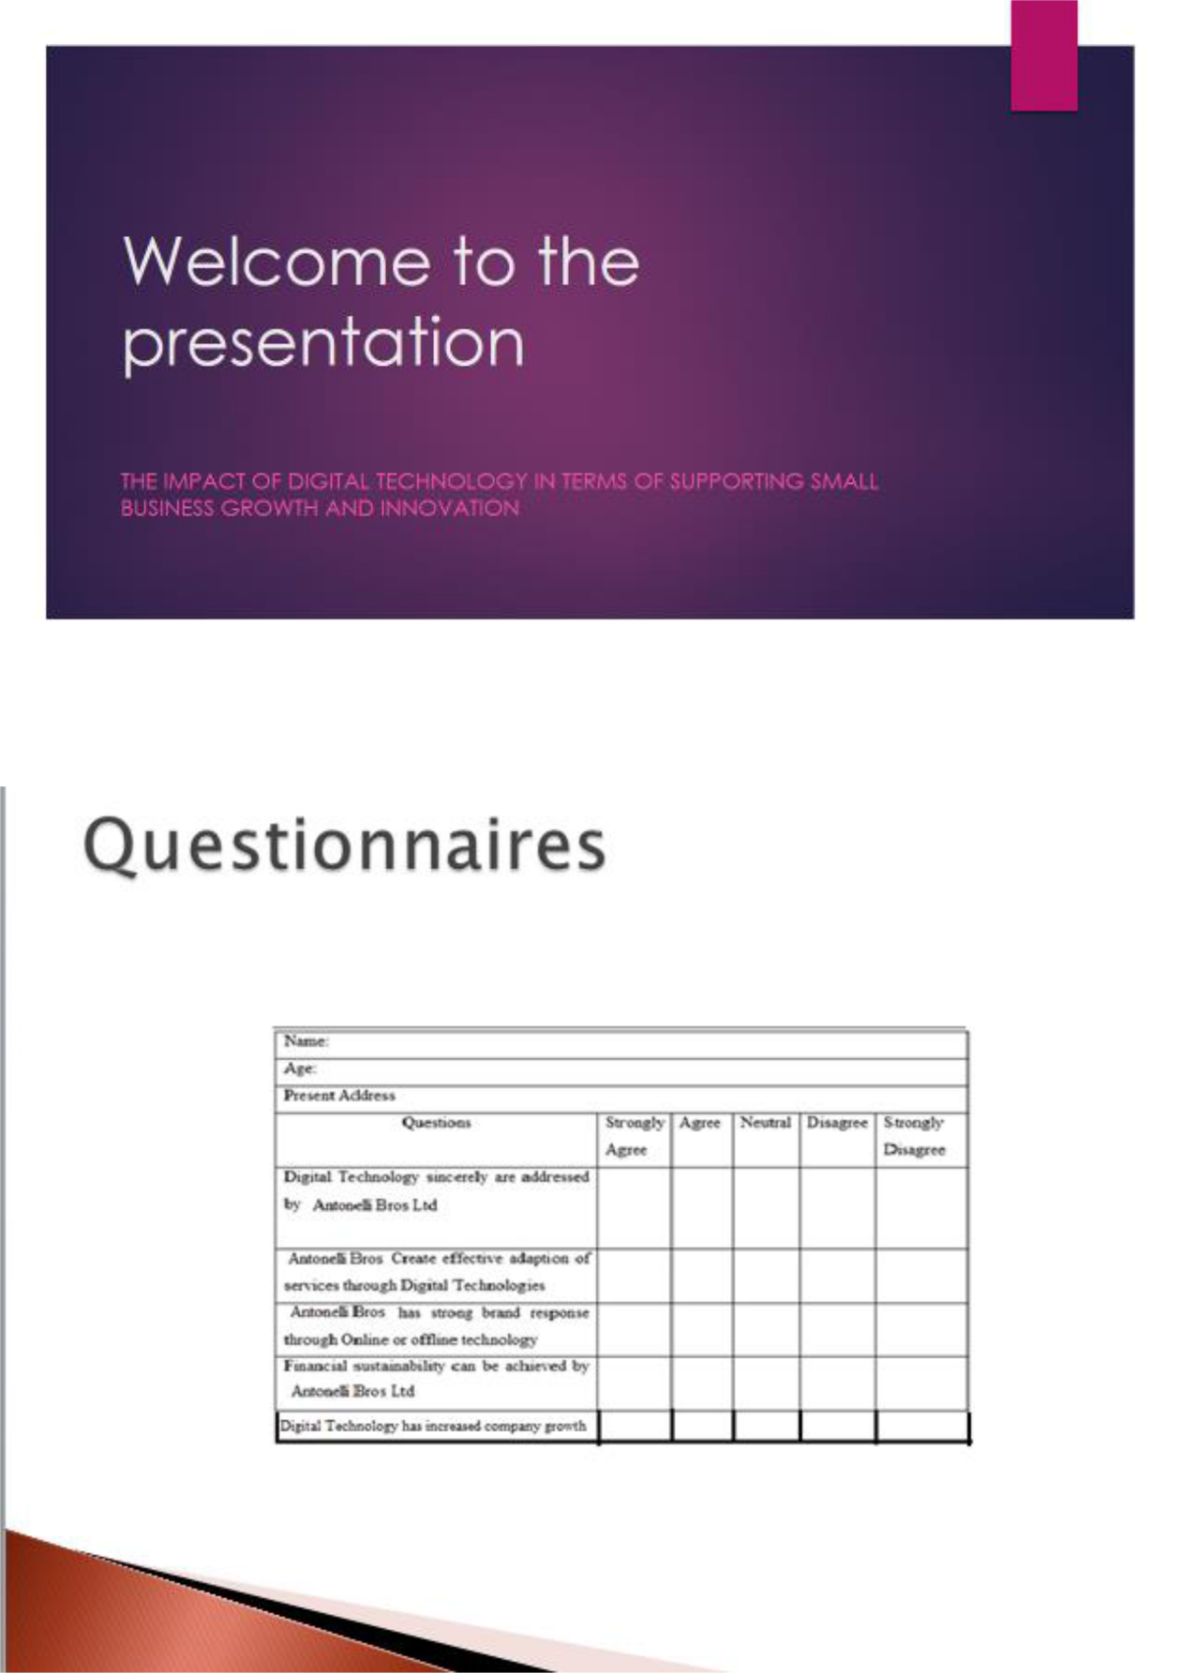

19

Slide 3:
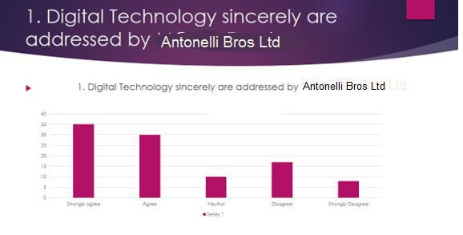

The collected data from the statement has showed that 35% of the participants of the research said strongly agree with the given statement which proved that Antonelli Bros Ltd practices and addressed the necessity of digital technology in the workplace. On the other hand, 8% of respondents has said the disagree option, that means Antonelli Bros Ltd do not addressed digital technology in the company premises.
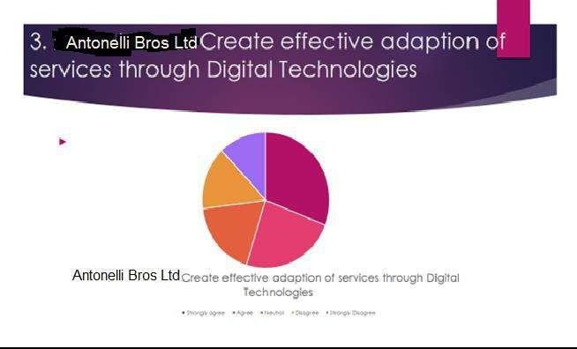

20

Towards the statement, 31% respondents said agree, that means Antonelli Bros Ltd provide a new

- good services to its customers to satisfy them with the help of digital technology. Again, 8% respondents think that Antonelli Bros Ltd had not adapted digital technology in their service; so they have chosen the disagree option.
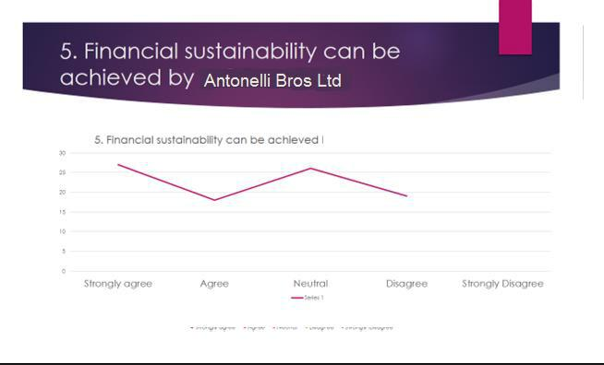

This statement is acting as a proof towards the achievement of Financial Sustainability in the company. Using digital technology in the business operation, Antonelli Bros Ltd has easily achieved financial sustainability in the workplace. Towards this statements, 27% respondents has chosen strongly agree option.

21

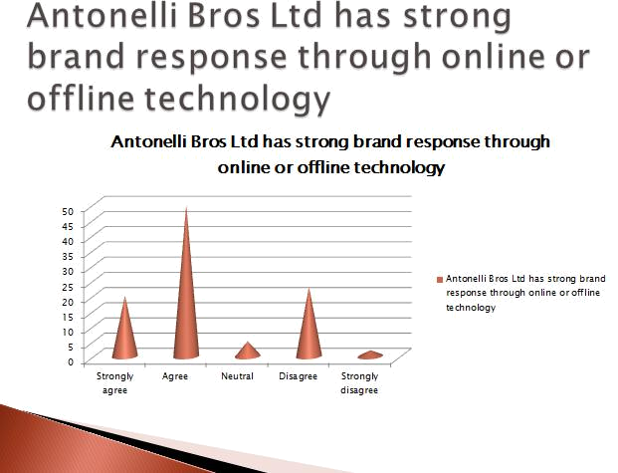

As per the research result, towards the statement Antonelli Bros Ltd has strong brand response through online or offline technology; 50 respondents has chosen the agree option. On the other hand, 23 respondents has chosen the disagree option.

22

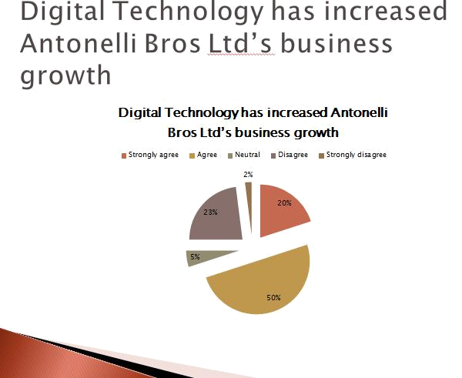

As per the research result, towards the statement Digital Technology has increased Antonelli Bros Ltd’s business growth; 50% respondents has chosen the agree option. On the other hand, 23% respondents has chosen the disagree option.

23

P6. Communication of appropriate recommendations because of research and data analysis to draw valid and meaningful conclusion
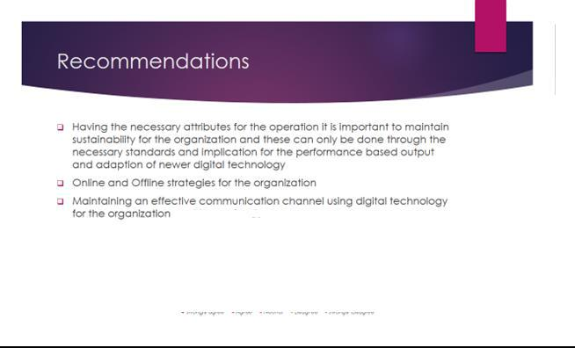

The following are the recommendation for Antonelli Bros Ltd to improve its business strategies:

- To maintain a growth in the operation in the business and to sustain in the market, a proper implication of digital technology is needed by the organization to enhance the company growth and company st6andards among the competitors (Holm and Jonas, 2004).

- Antonelli Bros Ltd should implement both different types of online & offline strategies to renovate its business operations to satisfy the customers. the company should focus more towards its online activities for the customers

- Antonelli Bros Ltd should innovate new manufacturing house to enhance the production quantity with the help of digital technology

- Digital technology should be used by Antonelli Bros Ltd to promote their business in the market.

- The company Antonelli Bros Ltd should communicate with its stakeholders through using the digital technology. It will make enable two way communication channels for Antonelli Bros Ltd.

24

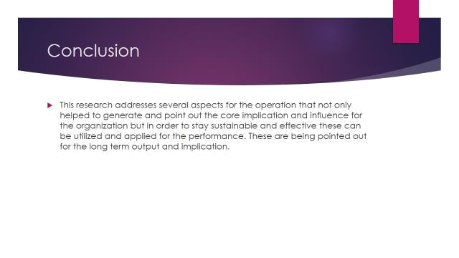

Today digital technology play is one of the most vital roles to shape up the business and its operations. In the modern business scenario, the impact of digital technology is positively high. At the end of this research projects, it has shown some important aspects for the researcher and for the company too. The project has showed the importance & effects of digital technology on the organization Antonelli Bros Ltd. Not only importance; the research result has showed that digital technology has help Antonelli Bros Ltd to improve its performance in the business industry. However, to understand the impact thoroughly a proper research should be done. This research paper has highlighted the key issues regarding digital technology and its impact on organizations. Some of the core issues were identified and their role to influence the output of the organizations has been identified. The researcher has also point out the core proposition and it has been utilized within the research.

25

P7. Reflection on the Value of Undertaking the Research to Meet the objectives and own learning and performance of this research

Reflection for the learning and practice:

This research paper helps me to understand the different areas to successfully conduct a research by following necessary steps of a particular project. All the steps and attributes were carefully carried out throughout the research in effective way. From Data Collection to data analysis all the necessary steps were followed as an important part of the research. To get an accurate result it is very important to understand how to carry out and analyse the collected data in an effective way. As a result, an implication concentrated on communication skills is also important for a research paper. Skilled output needed to demonstrate and represent by the research in an effective manner. By following the processes communication skills has improved drastically as a result, the core competencies of the organisation also improved. However, there were many issues but the management of these issues were done in an effective manner. In this research paper, several issues were identified and dealt with.

Cycle of Reflection:

By using the findings that carried out throughout the research, there is a way to deal with the future of behaviour within the research. It could be done in a practical manner. The findings of the research will be used to identify necessary framework and propositions. It will help to make decisions about the behaviour for the research.

Now a day it is inevitable that digital technology has some great impact in every organisations. Different organisations have their own way to address the necessity of digital technology and adopt of digital technology like Antonelli Bros Ltd. In this research paper, I have learnt that digital technology may help organisations to ensure better quality in the most effective manner.

I have also learnt that by using digital technology organisations can improve their growth rate and innovation with the help of different strategic plans. By adopting digital technology, organisations will be able to offer better support to the customers.

Success and Gaps:

26

Diesel Technology helps organisations to improve its operational process. As a result, the competitiveness of digital technology addressed by conducting a successful research. The result validated by using proper data and analysis of the data. In this research paper it has been carried out successfully by highlighting the key attributes. Future recommendations and strategies based on the result also shown in this research paper (Bne Saad, 2013).

On the other hand, the relative path of the Strategies and its implications showed by using necessary implications in the research paper.

One of the core issues for the research paper was that Data Collection process was hard and it was very difficult to present the data useful what is research paper to show that diesel technology is effective for our organisation in the long run.

Hurdles and ways to Overcome:

- For this research paper one of the core issues was the privacy of the organisation. Proper Assurance were given to the organisation about the performance base objectives and its implications.

- There were many responses that were indifferent for the core objectives of the research but these responses were checked practically.

Learning from the Research

- In this research paper different attributes and aspects of the digital Technology were addressed and then applied in the research paper. By using these attributes, the researcher was able to find out the core competencies and implications for the organisations about digital Technologies. In this research paper, several key areas to conduct the research in a practical way were identified.

27

- Different types of issues were dealt with by providing proper resolutions throughout the research based on the impact of digital technology on organisations.

- In this research paper, the impact of customers perception has been highlighted as well as their ability to point out the key issues of organisations has also been highlighted. The research paper will help to improve different areas of analysis and help to make decisions efficiently. I have also learnt the impact of digital technology and small and medium organisations from this research paper.

- I have also learnt different aspects of job satisfaction of the employees based on digital technology and how it will improve the core competency of the organisation in the long run. I also learnt Different aspects of digital technology and their impact on the organisation as a whole and its people.

28

Conclusion

Today digital technology play is one of the most vital roles to shape up the business and its operations. In the modern business scenario, the impact of digital technology is positively high. However, to understand the impact thoroughly a proper research should be done. This research paper has highlighted the key issues regarding digital technology and its impact on organizations. Some of the core issues were identified and their role to influence the output of the organizations has been identified. The researcher has also point out the core proposition and it has been utilized within the research.

29

References

Flick, U. (2011) Introducing Research Methodology: A Beginner’s Guide to Doing a Research

Project. London: SAGE.

Gray, D. (2009) Doing Research in the Real World. 2nd Ed. London: SAGE.

Saunders, M., Lewis, P. and Thornhill, A. (2012) Research Methods for Business Students. 6th Ed. Harlow: Pearson.

Cooke, H., Tate, K. and Cooke, H. (2011).Project management. 1st ed. New York: McGraw-Hill.

Maylor, H. (2010). Project management. 1st ed. Harlow, England: Financial Times Prentice Hall.

Baguley, P. (2008). Project management. 1st ed. London: Hodder Education.

Khosrow-Pour, M. (2004). The social and cognitive impacts of e-commerce on modern organizations. Hershey PA: Idea Group Pub.

Konstadakopulos, D. (2004). Learning for innovation in the global knowledge economy. Bristol:

Intellect Books.

Lazar, J. (2002). Managing IT/community partnerships in the 21st century. Hershey, PA: Idea Group Pub.

McKelvey, M., Rickne, A. and Laage-Hellman, J. (2004). The economic dynamics of modern biotechnology. Cheltenham, UK: Edward Elgar.

Tomsen, M. and Faith, R. (2003). Reaching the interactive customer. Cambridge, UK: Cambridge University Press.

Valik, D. (2013). Microsoft Lync 2013 Unified Communications. Birmingham, UK: Packt Pub.

Archer, N. & Yuan, Y. F. (2000) Managing business-to-business relationships throughout the e-commerce procurement life cycle. Internet Research-Electronic Networking Applications and Policy, 10, 385- 395.

Croteau, A.M., & Bergeron, F. (2001). An Information Technology Trilogy: Business Strategy, Technological Deployment, and Organizational Performance. Journal of Strategic Information Systems, vol. 10, 77-99.

30

31

